# 2.2 ENTITY RELATIONSHIP DIAGRAM

The following ER-diagram represent the relationship between all the entities such as CUSTOMER, SUPPLIER, SALES, etc. How the interaction takes places between each tables present in database as shown in fig 2.2

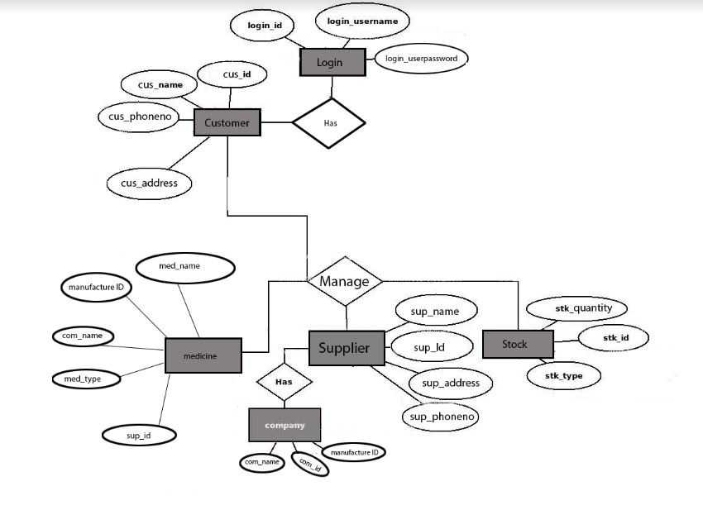

**Fig 2.2: ER-diagram for Medical Clinic Management**